Experiment No. 7

Title:
Perform DOM traversal and updates; develop a to-do list app with add, edit, and delete features.

Software / Tools Required:
- Visual Studio Code (VS Code)
- Google Chrome (Browser)

Theory:
This experiment explores the Document Object Model (DOM) interface, focusing on structural traversal, dynamic element manipulation, and event handling within a web application. The core theoretical pillars implemented include:
- Dynamic DOM Tree Manipulation: The application utilizes methods such as document.getElementById() to fetch container components and document.createElement() to construct new elements structurally. Data insertion and node updates are executed dynamically using properties like innerHTML, appendChild(), and replaceChild().
- DOM Traversal: To target related elements across complex interactions, the script implements structural traversal properties like parentElement. This allows child nodes (such as target click buttons) to cleanly identify and alter their parent list item containers (<li>) without relying on hardcoded unique identifiers.
- Event Delegation: Instead of attaching discrete event listeners to every single button added to the list, a single event listener is attached to the parent containment element (#taskList). The event handler uses e.target to determine which specific button was clicked, routing the operation appropriately.
- State Control & Conditional Toggles: The logic incorporates interface state alterations, managing text modifications by substituting elements with editable <input> text boxes. It updates conditional class listings (completed) to dynamically apply visual text decorations based on checkbox states.

AIM OF THE CASE STUDY :
To design and develop a smart, role-based to do application that helps users manage time effectively by scheduling alarms according to different activities such as study, sleep, work, fitness, and custom events, while improving productivity, routine tracking, and user convenience.

Name : Parth Dhoke
PRN : 24070521257

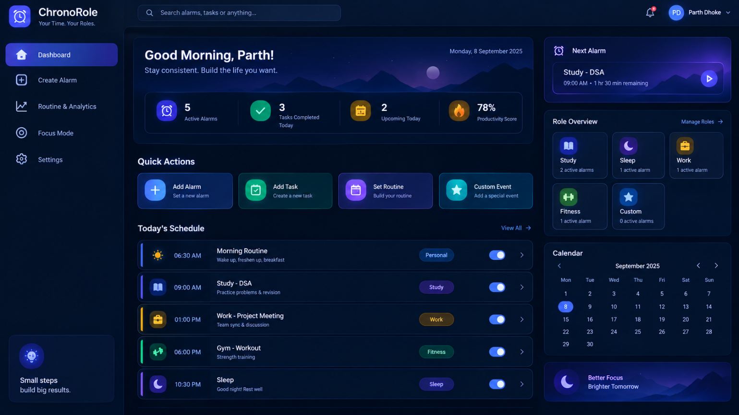

Output :
This case study focuses on designing and implementing a role-based alarm application that promotes productivity, time management, and habit formation. The application will provide multiple alarm categories, live clock updates, countdowns, custom tones, and alert notifications to help users stay organized in their daily routines. By using JavaScript and web technologies, the project demonstrates how interactive systems can be created to solve real-life scheduling problems efficiently and effectively.

Result / Conclusion :
In conclusion, this experiment demonstrated real-time DOM tree manipulation and traversal by building a fully functional, empty-by-default To-Do List application. By leveraging node traversal methods (parentElement) and centralized event delegation on the parent container, the program smoothly handled adding new items, toggling visual completion states, replacing elements with inline edit boxes, and removing items on demand. The visual output confirmed the absolute correctness of the script, showcasing accurate tracking of the live task counter and immediate element updates .

